Robotic Systems in Manipulation - Phase I: Kinematics

Name: Rodrigo Sales Freire dos Santos | ist1119658
Name: Mikhail Mohamed Shueb | ist1104014

Step 5:

In this step, we implemented the Closed-Loop Inverse Kinematics controller using the forward kinematics and geometric Jacobian models developed in the previous steps. The main point behind CLIK is that instead of computing one closed-form joint solution directly, the robot continuously corrects its joint velocity from the measured task-space error.

The controller was implemented in clik_controller.m and integrated into the Simulink model Kuka_CLIK_Model.slx. At each simulation instant, the current end-effector pose is computed using forward kinematics. The position error and the orientation error is computed with the angle-axis representation of the rotation error, given by

$e_p = p_d - p$

$R_{err}= R_{d} R^{T}{}^{}$

Since this model of KUKA robot is redundant, this is what the controller uses the damped pseudoinverse of the Jacobian:

$J^{\#} = J^{T} (J J^{T} +λ{}^{2} I)^{-1}$

together with null-space stabilization:

In the code, the null-space gain is named “Kn”, but in the report it is written as “K_0”. The baseline value was “K_0 = 0.15 I_7”, with “q_rest = 0”, so that the robot is gently pulled toward a central resting posture without changing the final end-effector pose. In the graphic below, we can observe the convergence of the position and orientation, as the error decreases, after 1 second.

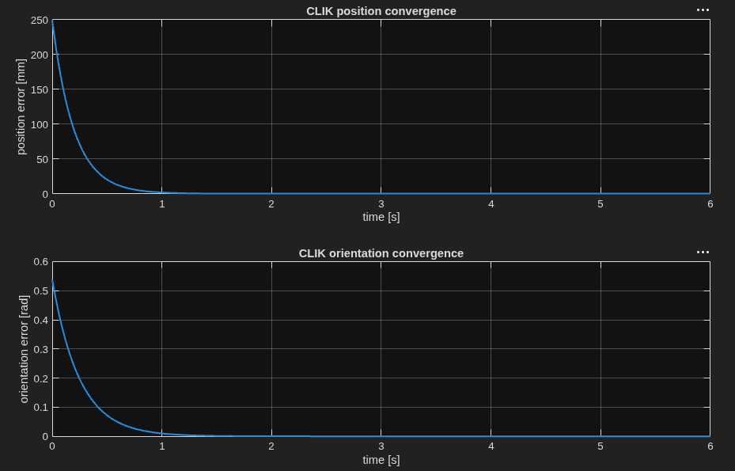

5.1 Validation Against Analytical Inverse Kinematics

First, a target pose was generated from a known joint configuration and the the desired pose ‘(p_d, R_d)’ was obtained through forward kinematics and then tested with the analytical inverse kinematics model from Step 3. The resulting error was practically zero:

Method | Position error | Orientation error
Analytical IK followed by DK | 1.18e-13 mm | 3.53e-16
CLIK, baseline case | 1.58e-4 mm | 2.06e-8

The CLIK result does not reach the same numerical zero as the analytical solution because it is a dynamic method, integrated over time, the robot is redundant and because the Jacobian inversion is damped but the final error is far below 1 mm. The goal and final joint configuration obtained in the baseline case was:

5.2 Influence of the Proportional Gain

Three proportional gain values were tested while keeping the same target, the same initial configuration, and ‘K_0 = 0.15’. The purpose was to observe how the gain affects convergence speed, stability, and joint effort.

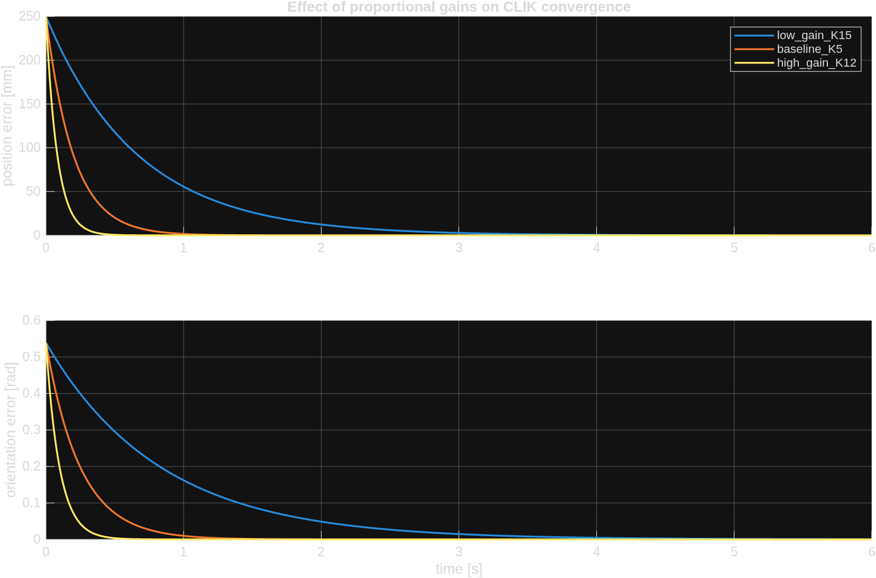
The low-gain case was stable, but it took longer to converge. The high-gain case converged much faster, but it required larger joint velocities. For the final model, the baseline case is a good compromise: it converges in approximately 1.1 s without producing joint velocities as aggressive as the high-gain case.

5.3 Influence of the Initial Joint Configuration

The redundancy of the manipulator was also tested again, using the same target pose was tested again with a different initial joint configuration:

Test | Final pos. error (mm) | Final ori. error (rad) | Settling time (s) | Largest absolute joint value (rad)
Baseline q_0 | 0.000158 | 1.0e-8 | 1.100 | 1.053
Different q_0 | 0.000157 | 1.0e-8 | 1.356 | 1.457

Both tests converged to the same Cartesian pose, but with different joint trajectories. This result confirms the expected behaviour of a 7-DOF robot: the end-effector task is satisfied, while the internal posture depends on the initial configuration and on the null-space term.

5.4 Null-Space Gain ‘K_0’

The next test compares the controller with and without null-space stabilization. In both cases, the end-effector converges to the desired target, but the internal joint posture changes.

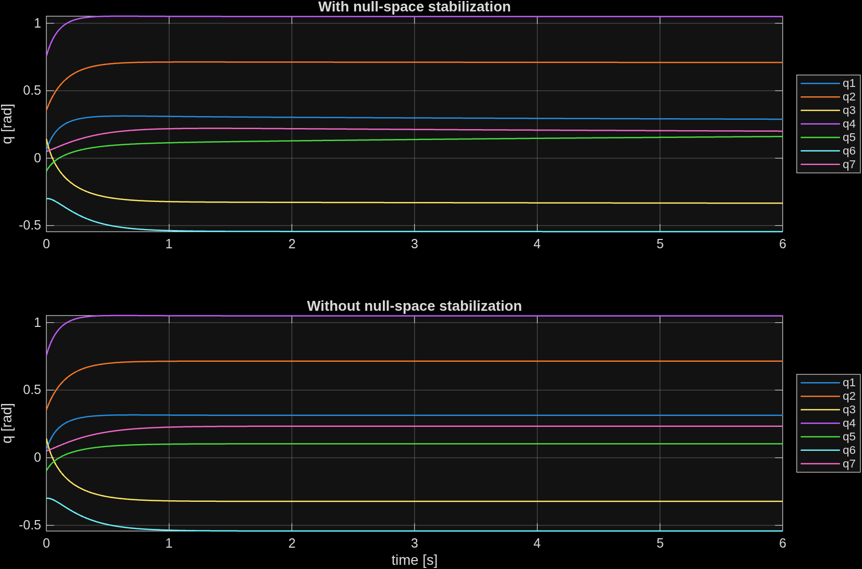

Test | K_0 | Final pos. error (mm) | Settling time (s) | Final distance to q_rest (rad)
With null-space term | 0.15 | 0.000158 | 1.100 | 1.4705
Without null-space term | 0.00 | 0.000000 | 1.100 | 1.4747

For this specific target, the final numerical difference is small because the motion is short and the initial posture is not very far from the resting posture. Even so, the joint plot shows that the null-space term changes how the redundancy is used. During repeated CLIK updates, this term prevents redundant joints from drifting toward uncomfortable configurations or mechanical limits.

5.5 Final Discussion

Our tests lead to three main conclusions. First, CLIK validates both the forward kinematics and the Jacobian, because it converges to the same pose as the analytical inverse kinematics with a very small error. Second, the proportional gain directly controls the trade-off between speed and joint effort: larger gains reduce settling time, but increase `qdot`. Third, the redundancy of the robot makes the null-space term important for controlling the internal posture without disturbing the main end-effector task.

